FOLLOW UP REPORT
January 2023
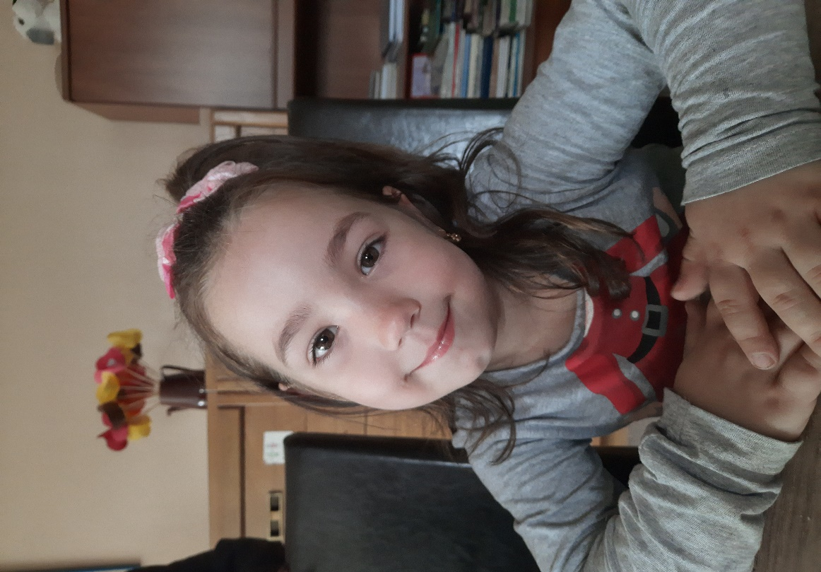
1. Reference No.: 274 RA
2. Surname: Purcariu
3. First name: Alexandra Maria
4. Date and birth place: August 4, 2016 / Reşiţa
5. Religion : Orthodoxian
6. Language spoken: Romanian
7. Address: Reşiţa, Caras Severin County
8. School: Primary School No.8 Resita
EDUCATION/HEALTH/SOCIO-ECONOMIC CONDITIONS:
Alexandra is very cute little girl! In August month, Alexandra turned 6 years old. Alexandra is enrolling on Preparatory class at Primary School No.8 in Resita.
Alexandra graduated kindergarten in June 10. She was happy to be in summer vacation till September month.
Alexandra is a good and obedient pupil in school and her results are very good.
Alexandra is clever girl and she loves to be in school. She likes very much the stories and also, she loves to paint. Alexandra likes Math field, and Romanian Language.
Alexandra and her family are very happy about her results in school.
Alexandra have started Preparatory class in 2022, September 5 and she enjoyed a lot to go to school and meet her friends from kindergarten.
Alexandra grants a lot of attention to the study hours and she like very much to be prepare for the next day. Alexandra is delighted by everything she learns in school. She has a good memory.
Alexandra is very involved in various activities at school. She sings in the school choir, recites poems at celebrations. On Christmas Day she sang carols on stage with her colleagues.
The school is in same neighborhood with the home of Alexandra and she walk 5 minuts together with her mother at school in the morning and back at noon.
Before starting first grade, children here have a class named Preparatory class. The preparatory class is a year of transition between kindergarten and school where children adapt more easily to school requirements.
Alexandra speaks very well for her ages. She is very comunicative and very sociable child. Alexandra loves to play together with other children.
Denisa is her big sister. Denisa will turn 17 years old in April month. Denisa is student in Xth grade at Baptist High School in Resita.She has good results in school.
In December, before Christmas, Alexandra was admitted to the hospital together with her mother in the pediatrics department of the Resita emergency hospital. Alexandra had a high fever and repeated asthma attacks and had to be admitted to the emergency room.
Alexandra went home for Christmas, but with great precautions and indications from the doctors.
Currently, Alexandra is fine, but her mother must take great care of her. Alexandra being a lively and playful child, runs to school, plays with other children, sweats and catches cold very easily.
Alexandra is a child with health problems. After birth, Alexandra spent many months in hospital with infection at stomach and asthma crises. She has often asthma crises and big fever. Especialy in cold season Alexandra has more often asthma crisis. In that days her mother protected her and kept her at home from school.
Alexandra and her mother were sick with Covid and they were hospitalized for two weeks in Caransebes Emergency Hopsital.
Alexandra feels good in the summer, but with the changes of the season and the cold, her asthma attacks intensify.
Denisa is a child with health issues too. Denisa, Alexandra's older sister, continues to have problems with the ear on which she was operated. She was also admitted to the hospital for a second surgical intervention in November month.
Her mother is not satisfied with the results and wants to find another doctor to continue treating Denisa.
Alexandra is member of family with four members, mother, father and big sister Denisa. Alexandra is very happy to have a sister, she loves very much Denisa .
Both of parents of Alexandra and Denisa were raised in orphanage of state, so both of them have psychological and behavioral problems. They are very nervous people. They often argue in front of the children, creating a lot of stress for the two girls.
Alexandra's family received a larger and cleaner one room apartment from the Town Hall. The two sisters share the big room which is also the living room where they do their home work and parents sleep in kitchen they have a bed there.
Our Organization, donated them furniture and supported the family, with everything they needed in order to move to this apartment. It is kept in order and tidiness.
Their present income is composed of:
- Vasile, the father, earns around 2000 lei (400 Euros) per month, he has a daily job.
- Alexandra’s allowance for sickness is 250 lei (50 Euros) per month.
- Denisa’s special support allowance for sickness of 250 lei (50 Euros) per month;
- The two state allowence 250 lei for two girls, 500 lei(100 Euros) per month.
Totally income is 600 Euro per month, too small for the needs of the family with sick children.
The support that Alexandra, received from her Norwegian sponsors is more than welcome for this family and received by them with very much gratitude! With your support money, Alexandra received kindergarten/school supplies, clothing and shoes, food supplies, hygiene products with ocassion of starting school in September month, Christmas, Easter, her birthday and for medical needs.
Alexandra and her family are thanking you very much for your constantly support! Alexandra and her family are wishing you, all the best in your life!

GENERAL REMARKS:
This year, prices exploded for all products and salaries, child allowances, pensions remained at the same level. Thus, the lives of people here, especialy families with many children have become more and more difficult. Now, firewood has become very expensive, but also gas and electricity, so that it is impossible for many families to pay such large amounts.
Unfortunately, Alexandra's family is in this category. They struggle from one month to the next. Alexandra needs are food supplies, clothes and shoes for winter season, school supplies and hygiene products.
Your help is very welcome for Alexandra and her family. For this family it is a warm feeling to know they are not alone, giving them the strength to keep fighting. All family sending you hugs and appreciation. God bless you all!

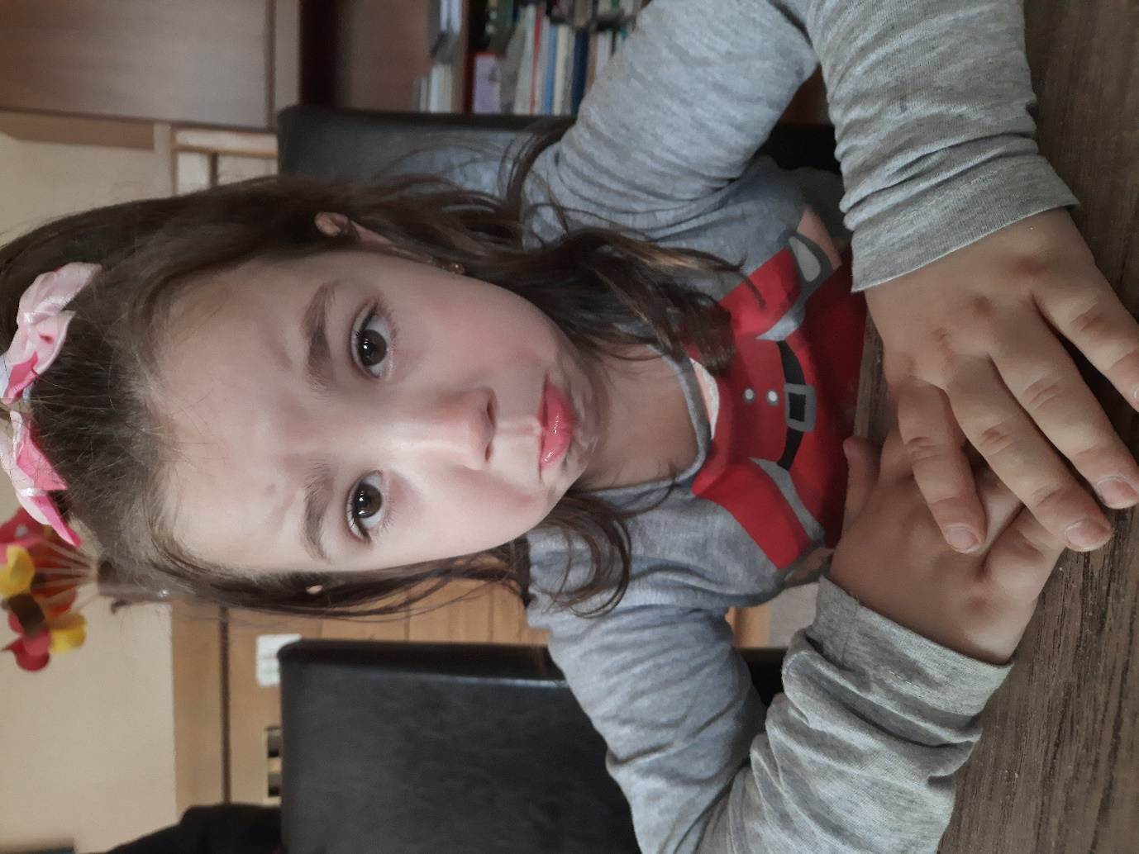
Alexandra wants to become an actress. She showed us how easily she changes her face.
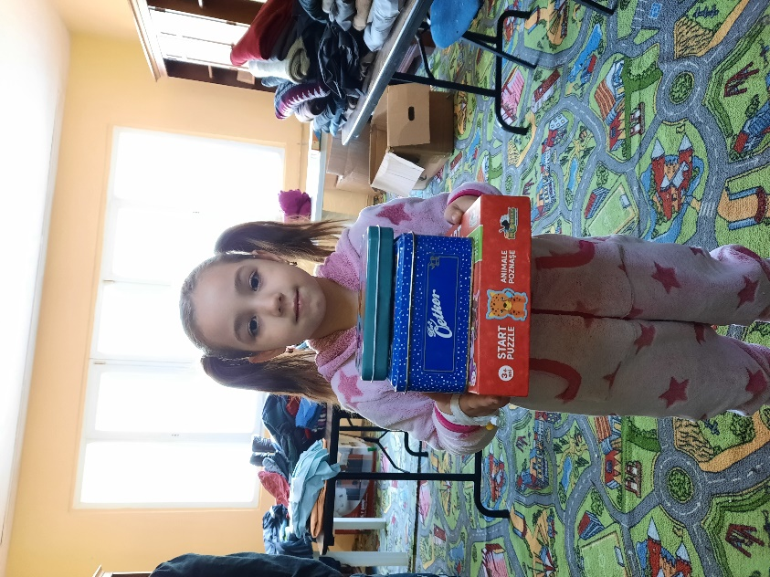

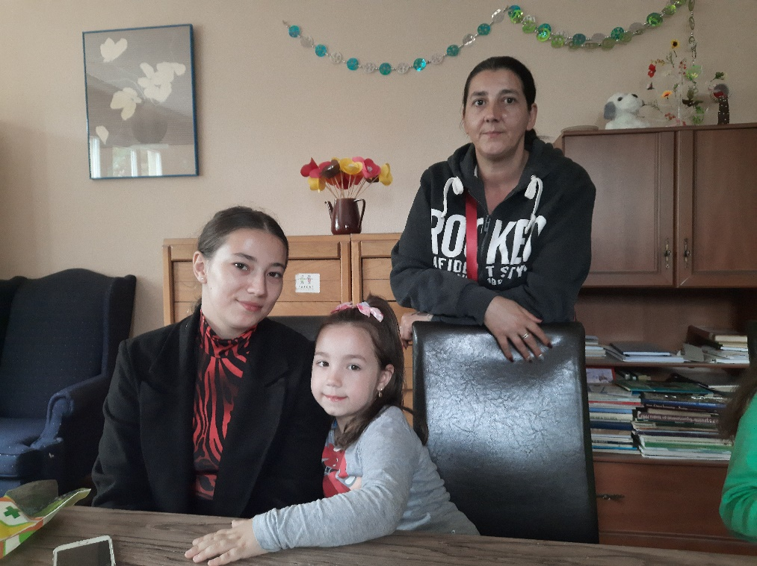

Maria Volintiru Elena Moise
Executive Director Social Worker

